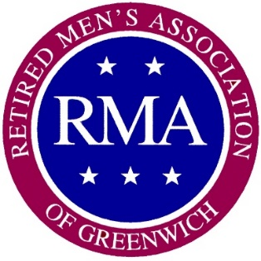
The Retired Men's Association of Greenwich, Inc.
37 Lafayette Place, Greenwich, CT 06830
www.greenwichrma.org

Participant Release Form
To Whom It May Concern:
I grant to the Retired Men's Association of Greenwich, Inc. (RMA), the right to photograph me and to record my voice, performances, poses, actions, plays and appearances, and use my picture, photograph, silhouette and other reproductions of my physical likeness in connection with the program at the RMA's meeting tentatively entitled:
______________________________________________________________
(Name of Program/Production)
I also grant to the Retired Men's Association of Greenwich, Inc., its successors, assigns and licensees, the perpetual right to use, as desired, all still and motion pictures and sound track recordings and records which RMA may create of me, my voice and my program material as presented, and the right to use my name or likeness in or in connection with exhibiting, advertising, using and/or publicizing of the program. I further grant the right to reproduce in any manner whatsoever any recordings, including instrumental, musical or other sound effects produced by me in connection with the production and/or postproduction of the video.
I agree that I will not assert or maintain against the Retired Men's Association of Greenwich, Inc., your successors, assigns and licensees any claim, action, suit or demand of any kind or nature whatsoever including, but not limited to, those grounded upon invasion of privacy, rights of publicity or other civil rights or for any reason in connection with your authorized use of my physical likeness and sound in the video as herein provided.
REMUNERATION: It is understood between both parties that there will be no remuneration.
Participant's Name
Address (Street, City, State):
Phone No.:
Signature:
Parent/Guardian Signature (if under 18):
Date:

