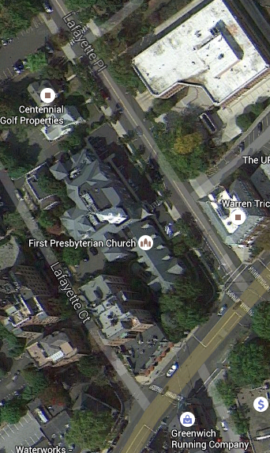

**Speaker Parking**

**Putnam Avenue**

**Route 1**

**East - West**

**Greenwich Avenue**

**One way south**

**Lafayette Place**

**Enter Here**

**Park Here**