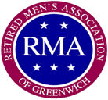
CIGAR BOX BULLETIN
Retired Men’s Association of Greenwich, Inc.
37 Lafayette Place, Greenwich, CT 06830
www.greenwichrma.org
Chair/Editor: Joe Mancinelli Graphics: Av Rivel
Scribes: Av Rivel, Arnold Gordon, Ed Farrell, Gerry Lessuk, George Stockbridge, Joe Mancinelli, Frank Scarpa, Marshall Toppo, Chet Risio.Archivist: Harold Frost. Format: Jack Cuff, Andrzej Mazurek. Print/Dist: Chet Risio
VOLUME 67 NUMBER 29 NOVEMBER 13, 2019 SCRIBE: JOE MANCINELLI

SPECIAL EDITION
Sixty-Fifth ANNUAL RMA DINNER
NOVEMBER 13, 2019
The Greenwich Retired Men’s Association celebrated its Sixty-Fifth Annual Luncheon Banquet at the Tamarack Country Club on Wednesday, November 13th, 2019. It was a well-attended, warm and cordial affair, thoroughly enjoyed by the attendees.
The actual Banquet meal was preceded with convivial mingling and friendly interaction among members, partners, friends and guests during the cocktail hour. Around noon the group gathered in the dining room where our Master of Ceremonies, RUSS HARDEN, First Vice President, formally opened the event with a gracious introduction and welcome to all the attendees.
Prior to the meal, JIM BUTLER provided an invocation. BOB BISHOP led the gathering in the Pledge of Allegiance followed by TOM HEALY with the Star-Spangled Banner, accompanied by BOB MORGAN on piano.
Past RMA Presidents were duly recognized and those present were asked to provide a photo opportunity on the front stage. See the photo below, (RALPH VIGGIANO, MIKE RYAN and GEORGE SHADDOCK were not present.)

DON CONWAY TOM HEALY
PETER UHRY RICHARD BARTHOLOMEW
RALPH VIGGIANO MIKE RYAN
BOB PHILLIPS JOHN CRAINE
GEORGE SHADDOCK SAM MARASSO
MIKE SMITH TAD LARRABEE

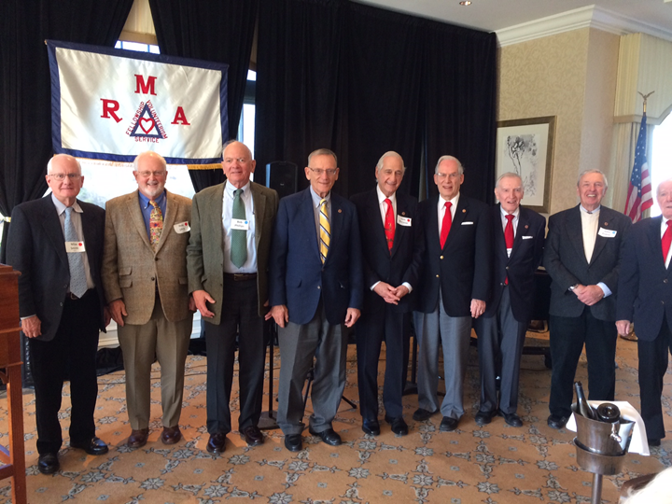
The Outstanding Service Award for this year was presented to both ARNOLD GORDON and CHET RISIO for their many contributions, volunteerism and overall support of the Greenwich RMA.
The RMA takes great pride in one of its key tenets of “Community Service”, accordingly, PETER STERN announced the 2019 Volunteer Awards with the three top volunteers being BOB RIMMER, with 885 hours, MICHAEL AMBROSINO with 967 hours and TAD LARRABEE with a total of 1,103 hours.
The RMA President, JERRY SCHWENDEMAN, delivered his special message enumerating the many redeeming features of the Retired Men’s Association including volunteer activities, social interaction and the overall fellowship among members. He also reflected upon his personal enjoyment and positive experience throughout the past year as President of the RMA.
Following a delicious desert, the crowd was treated to entertainment by the RMA’s Melody Men, let by TOM HEALY with BOB MORGAN on piano, MIKE HAYDEN on harmonica and JEFF JUNKER on the trombone. Their tunes including Downtown, Piano Man, a medley from Oklahoma and a solo by President JEERY SCHWENDEMAN on Nice Work If You Can Get It.
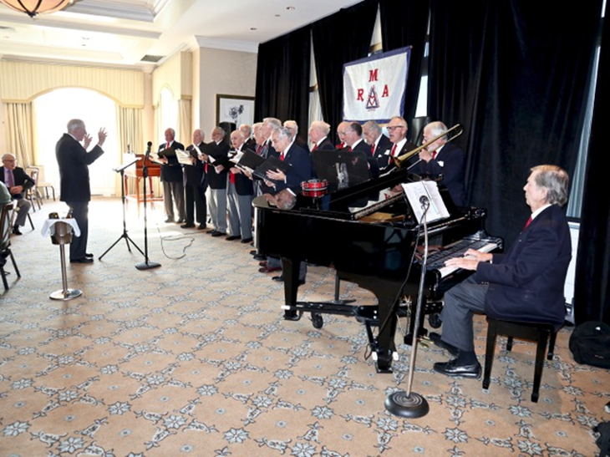
The affair was warmly concluded with TOM HEALY asking everyone to join in the traditional farewell tune of Till We Meet Again. It was one of CHUCK STANDARD’s favorites and a reflection of his incredible positive attitude. The RMA has adopted this tune as one of our favorite themes in honor of CHUCK and as an indication of the RMA spirit.
A much deserved thank you goes to RUSS HARDEN as the Chairman and organizer of this year’s Annual Banquet, it was a smashing success. An additional thank you goes out to his committee and support team:
MICHAEL AMBROSINO Vice Chairman
PETER STERN, ANDY & SHARON HOLMES Reception Tables
MICHAEL & LYNN AMBROSINO Table Flowers
TAD LARRABEE & JERRY SCHWENDEMAN Administrative Advisors
Bev Smith Program Administrator
MICHAEL AMBROSINO Second VP & Greeter
GARY MILLER Greeter
JIM BOARDMAN Greeter

